# 云计算国赛大数据开发梳理

红色高亮的代码是需要修改的代码

## 导入开发环境

检查已安装的 MongoDB，HBase，MySQL 本地服务，解压 guosai-xueqing.rar 学情开发框架项目，搭建大数据学情开发环境。

1. 导入三个 MongoDB 数据库目录 employ，job_internet，question_survey;
2. 导入 MySQL 的 xueqing-client 项目的 sql 文件 xueqing-client.sql; (3)导入 xueqing-web 项目并运行。

略

1. HBase 建表操作  
   完成 xueqing-server 之中 HBase 建数据库表的过程，建立总表和相应的行业表，运行后提交代码与 HBase 中表的查询结果。

打开xueqing-server，进入com.xiandian.douxue.insight.server.dao.HBaseStorage.java

将setUp函数里的HbaseConfiguration

**public** **void** setUp(String url, String port,String path) {

Configuration conf = HBaseConfiguration.*create*();

// 取得一个数据库连接的配置参数对象

conf = HBaseConfiguration.*create*();

// 设置连接参数：HBase数据库所在的主机IP

conf.set("hbase.zookeeper.quorum", url);

// 设置连接参数：HBase数据库使用的端口

conf.set("hbase.zookeeper.property.clientPort", port);

// conf.set("hbase.master", "192.168.137.25:9001");

conf.set("zookeeper.znode.parent", path);

// 取得一个数据库连接对象

**try** {

*connection* = ConnectionFactory.*createConnection*(conf);

*admin* = *connection*.getAdmin();

// 取得一个数据库元数据操作对象

logger.info("HBase connection successfully!");

} **catch** (Exception exc) {

logger.error(exc.toString());

}

}

提前为全局变量：

**public** **class** HBaseStorage {

**private** Logger logger = LoggerFactory.*getLogger*(getClass());

// 与HBase数据库的连接对象

**static** Connection *connection*;

// 数据库元数据操作对象

**private** **static** Admin *admin*;

**private** Configuration conf = HBaseConfiguration.*create*();

在createTable函数中加入代码

/**

* 创建表

*/

**public** **void** createTable(String tablename,String families) **throws** IOException {/////

HBaseAdmin baseAdmin=**new** ~~HBaseAdmin~~(conf);

HTableDescriptor tableDescriptor = **new** ~~HTableDescriptor~~(tablename);

String[] familiesList=families.split(",");

**for**(String family:familiesList) {

HColumnDescriptor columnDescriptor=**new** HColumnDescriptor(family);

tableDescriptor.addFamily(columnDescriptor);

}

baseAdmin.createTable(tableDescriptor);

}

在main函数里修改服务器地址

**public** **static** **void** main(String[] args) {

HBaseStorage baseStorage=HBaseStorage.*getInstance*();

baseStorage.setUp("192.168.108.130", "2181","/hbase");

**try** {

baseStorage.createTable("job_internet", "RAW_DATA,TAG_DATA,PERCEPT_DATA");

baseStorage.createTable("job_cloud", "cloud");

} **catch** (IOException e) {

// **TODO** Auto-generated catch block

e.printStackTrace();

}

}

运行HBaseStorage.java，查看HBase数据库

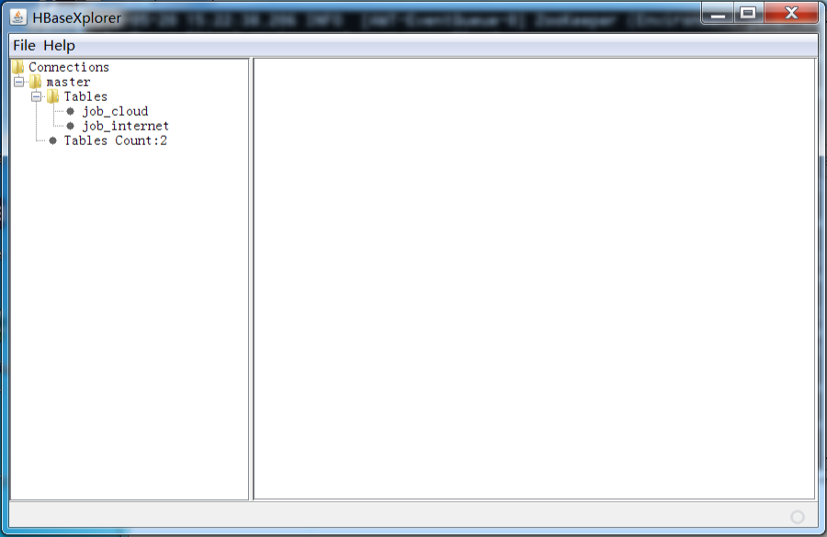

## 爬取岗位信息

通过解析网站(xueqing-web)源代码，抓取所有岗位页面信息中的岗位名称，发布日期，薪水条件，招聘人数，学历要求，工作经验年限，岗位描述等信息，爬取的信息存入指定的 HBase 表。运行后提交代码与 HBase 中表的查询结果。

复制xueqing-web项目com.xiandian.cloud.common.jobcollect.WYJobPageCrawler.java里的process函数里的所有代码

/**

* 爬虫单个页面的处理方法

*/

@Override

**public** **void** process(Page page) {

// Init select and urls

Selectable select = **null**;

List<String> urls = **null**;

// 如果是下一级别的内容

**if** (page.getUrl().toString()

.contains("search.51job.com")) {

// ?

select = page.getHtml().xpath("//p[@class='t1']");

urls = select.links().all();

page.addTargetRequests(urls);

// ?

select = page.getHtml().xpath("//div[@class='dw_page']");

urls = select.links().all();

// ?

Iterator<String> it = urls.iterator();

// ?

**while** (it.hasNext()) {

String x = it.next();

**if** (x.equals(urlBreaks)) {

it.remove();

}

}

// 收集下一级的url

page.addTargetRequests(urls);

}

// 岗位页面

**else** **if** (page.getUrl().toString()

.startsWith("http://jobs.51job.com/")) {

**try** {

Map<String, Object> map = **new** HashMap<>();

// **TODO**: 每个页面不能重新读取配置，每次爬虫任务

String JsonContext = ReadFile

.*ReadFile*("D:\\job_config.json");

JSONObject jsonObject = **new** JSONObject(JsonContext);

JSONArray wbsites = jsonObject.getJSONArray("wbsites");

**for** (**int** i = 0; i < wbsites.length(); i++) {

JSONObject wbsite = wbsites.getJSONObject(i);

String wbsitename = wbsite.getString("wbsitename");

**if** (wbsitename.equals("51Job")) {

// 设置来源

map.put("resource", wbsitename);

JSONArray fields = wbsite.getJSONArray("fields");

**for** (**int** j = 0; j < fields.length(); j++) {

JSONObject field = fields.getJSONObject(j);

String chinesename = field.getString("chinesename");

String name = field.getString("name");

String path = field.getString("path");

// ?

**if** (path.startsWith("//")) {

String objectStr = Format_transform.*gb2312ToUtf8*(page.getHtml().xpath(path).toString());

map.put(name, Format_transform.*change*(objectStr));

} **else** {

String objectStr = Format_transform.*gb2312ToUtf8*(page.getHtml().regex(path).toString());

logger.info(chinesename + ":" + objectStr);

map.put(name, Format_transform.*change*(objectStr));

}

// ?

**if** (name.equals("companymess")) {

String companymess = Format_transform

.*gb2312ToUtf8*(page.getHtml().xpath(path).toString());

String[] strs = UtilTools.*parseCompony*(companymess);

map.put("nature", Format_transform.*change*(strs[0]));

map.put("scale", Format_transform.*change*(strs[1]));

map.put("industry", Format_transform.*change*(strs[2]));

}

}

}

}

// 设置url

map.put("url", page.getUrl().toString());

// 设置岗位ID

Matcher matcher = pattern.matcher(page.getUrl().toString());

String pageID = **null**;

**while** (matcher.find()) {

pageID = matcher.group(1);

}

// 如果没有ID，不处理

**if** (pageID == **null**) {

**return**;

}

// 网址是否已经爬取

**boolean** isExist = **false**;

// isExist = jobDataReposity.queryByTwoId("job_internet", "TAG_DATA", "ID", pageID);

// 保存到HBase中，并设置结束日期为明天

**if** (pageID != **null** && isExist == **false**) {

map.put("id", pageID);

// 需要常量

// map.put(HDFS, job_rawdata_path + pageID + Suffix);

// jobDataReposity.insert("job_internet", map);

// DownloadHtml.Save(page.getUrl().toString(), job_rawdata_path);

} **else** {

// 找到这个岗位，设置它的结束日期为今天+1

// jobDataReposity.insertEndTime("job_internet", map);

}

} **catch** (Exception exp) {

logger.error(page.getUrl() + exp.toString());

}

}

}

到xueqing-server的com.xiandian.douxue.insight.server.service.job.collect.WYJobPageCrawler.java的process函数并作修改

/**

* 爬虫单个页面的处理方法

*/

@Override

**public** **void** process(Page page) {

// Init select and urls

Selectable select = **null**;

List<String> urls = **null**;

// 如果是下一级别的内容

**if** (page.getUrl().toString().contains("http://localhost:8080/xueqing-web/course/index/")) {

// ?

select = page.getHtml().xpath("//p[@class='PositionName']//a");

urls = select.links().all();

page.addTargetRequests(urls);

// ?

select = page.getHtml().xpath("//div[@class='dw_page']");

urls = select.links().all();

// ?

Iterator<String> it = urls.iterator();

// ?

**while** (it.hasNext()) {

String x = it.next();

**if** (x.equals(breakUrl)) {

it.remove();

}

}

// 收集下一级的url

page.addTargetRequests(urls);

}

// 岗位页面

**else** **if** (page.getUrl().toString().startsWith("http://localhost:8080/xueqing-web/")) {

**try** {

Map<String, Object> map = **new** HashMap<>();

// **TODO**: 每个页面不能重新读取配置，每次爬虫任务

String JsonContext = ReadFile

.*ReadFile*(System.*getProperty*("user.dir") + "/configuration/job_config.json");

JSONObject jsonObject = **new** JSONObject(JsonContext);

JSONArray wbsites = jsonObject.getJSONArray("wbsites");

**for** (**int** i = 0; i < wbsites.length(); i++) {

JSONObject wbsite = wbsites.getJSONObject(i);

String wbsitename = wbsite.getString("wbsitename");

**if** (wbsitename.equals("51Job")) {

// 设置来源

map.put("resource", wbsitename);

JSONArray fields = wbsite.getJSONArray("fields");

**for** (**int** j = 0; j < fields.length(); j++) {

JSONObject field = fields.getJSONObject(j);

String chinesename = field.getString("chinesename");

String name = field.getString("name");

String path = field.getString("path");

**if** (name.equals("companymess")) {

String companymess = Format_transform

.*gb2312ToUtf8*(page.getHtml().xpath(path).toString());

String[] strs = UtilTools.*parseCompony*(companymess);

map.put("nature", Format_transform.*change*(strs[0]));

map.put("scale", Format_transform.*change*(strs[1]));

map.put("industry", Format_transform.*change*(strs[2]));

} **else** {

// ?

**if** (path.startsWith("//")) {

String objectStr = Format_transform

.*gb2312ToUtf8*(page.getHtml().xpath(path).toString());

logger.info(chinesename + ":" + objectStr);

map.put(name, Format_transform.*change*(objectStr));

} **else** {

String objectStr = Format_transform

.*gb2312ToUtf8*(page.getHtml().regex(path).toString());

logger.info(chinesename + ":" + objectStr);

map.put(name, Format_transform.*change*(objectStr));

}

// ?

}

}

}

}

// 设置url

map.put("url", page.getUrl().toString());

// 设置岗位ID

Matcher matcher = pattern.matcher(page.getUrl().toString());

String pageID = **null**;

**while** (matcher.find()) {

pageID = matcher.group(1);

}

// 如果没有ID，不处理

**if** (pageID == **null**) {

**return**;

}

// 网址是否已经爬取

**boolean** isExist = **false**;

isExist = jobDataReposity.queryDataById("job_internet", "TAG_DATA", "ID", pageID);

// 保存到HBase中，并设置结束日期为明天

**if** (pageID != **null** && isExist == **false**) {

map.put("id", pageID);

// 需要常量

map.put(***HDFS***, job_rawdata_path + pageID + ***Suffix***);

jobDataReposity.insertData("job_internet", map);

// DownloadHtml.Save(page.getUrl().toString(), job_rawdata_path);

} **else** {

// 找到这个岗位，设置它的结束日期为今天+1

jobDataReposity.insertEndTime("job_internet", map);

}

} **catch** (Exception exp) {

logger.error(page.getUrl() + exp.toString());

}

}

}

在com.xiandian.douxue.insight.server.service.job.JobAnalysisService.java里启动收集服务并运行com.xiandian.douxue.insight.server.EduInsightServer.java，查看Hbase数据库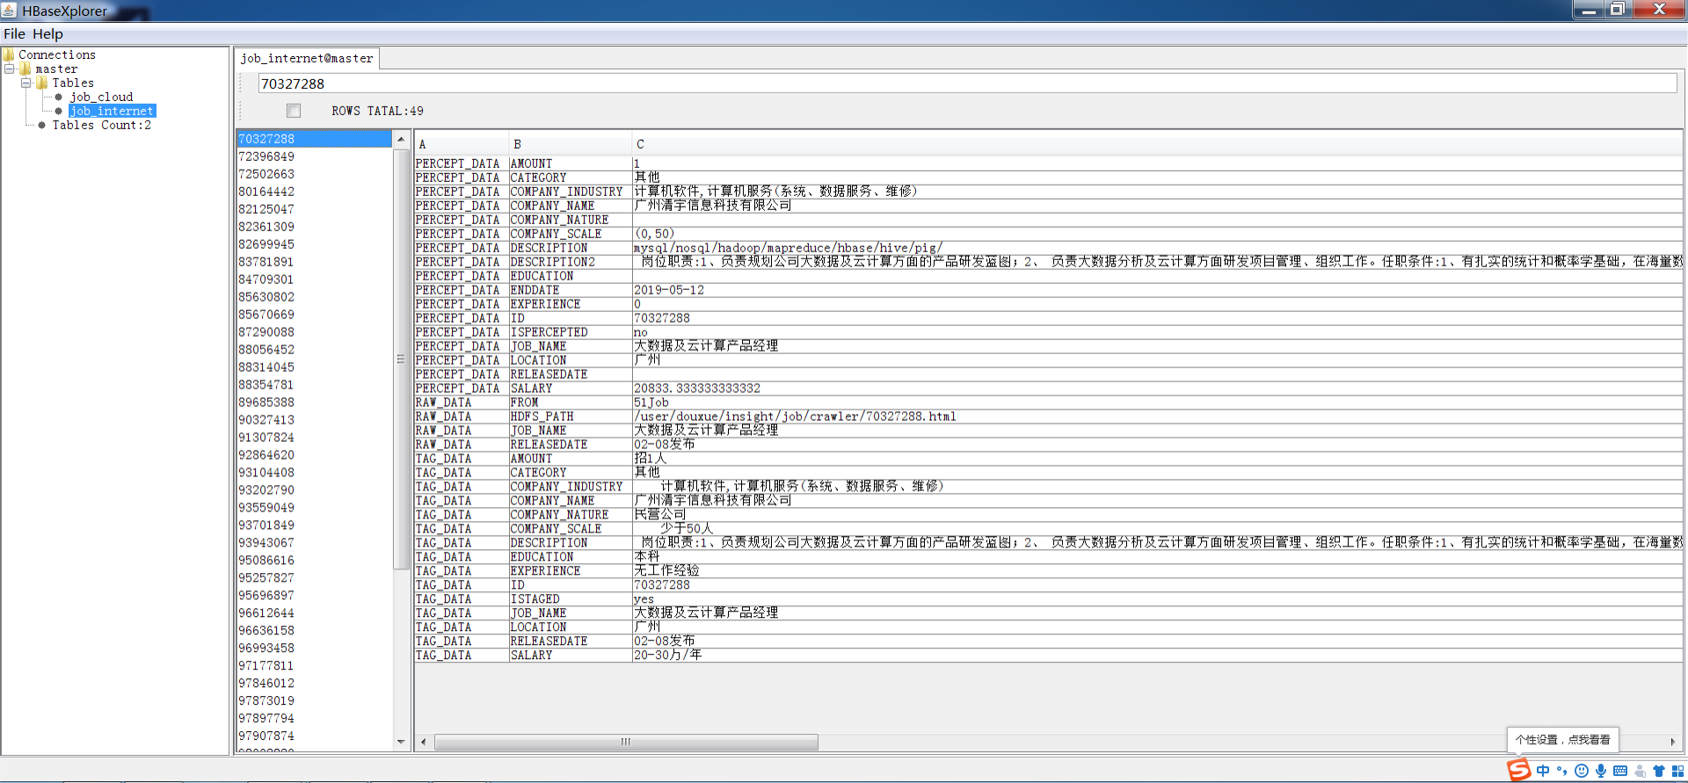

## 对爬取的岗位信息清洗

使用 HBase 中保存的岗位信息，根据指定的数据转换规则，对指定的列族 和列的地区分布、学历分布、薪资分布、企业规模、企业性质、工作经验等数据 进行清洗。

在com.xiandian.douxue.insight.server.service.job.clean.JobCleanService.java的process函数里加入代码

/**

* 具体的实现。

*/

**public** **synchronized** ServiceState process() {/////

**try** {

*jobDataReposity*.cleanJobData();

} **catch** (Exception e) {

e.printStackTrace();

}

**return** ServiceState.***STATE_RUNNING***;

}

在com.xiandian.douxue.insight.server.service.job.JobAnalysisService.java里启动清洗服务并运行com.xiandian.douxue.insight.server.EduInsightServer.java

## 岗位数据统计

完成 xueqing-server 之中爬取的岗位信息数据进行数据统计，将数据保存至 MongoDB 之中，实现 Web 前端代码并通过指定 EChart 的图表可视化展示岗位 地区分布、学历分布、薪资分布、企业规模、企业性质、工作经验等统计可视化 数据开发。

地区分布默认已实现，源代码如下

/**

* 岗位省份分布

*

* **@param** stmt

* **@param** tableName

* **@throws** SQLException

* **@throws** IOException

*/

**public** **void** countProvinceDistribution(String tableName, String mongoTable, String family) **throws** SQLException, IOException {

MongoClient mongoClient = mongodbstorage.setUp();

// String sql = "select LOCATION,count(1) as count,sum(AMOUNT) from " +

// tableName

// + " where ISPERCEPTED = 'no' group by LOCATION order by count desc";

// ResultSet results = stmt.executeQuery(sql);

// 建立表的连接

Table table = *connection*.getTable(TableName.*valueOf*(tableName));

// 创建一个空的Scan实例

Scan scan1 = **new** Scan();

// 可以指定具体的列族列

scan1.addColumn(Bytes.*toBytes*(family), Bytes.*toBytes*("LOCATION")).addColumn(Bytes.*toBytes*(family),

Bytes.*toBytes*("AMOUNT"));

scan1.setCaching(60);

scan1.setMaxResultSize(1 * 1024 * 1024); // 100k （MB1 * 1024 * 1024）

scan1.setFilter(**new** PageFilter(1000));

// 在行上获取遍历器

ResultScanner scanner1 = table.getScanner(scan1);

Map map = mongodbstorage.create(mongoTable, "job_province_distribution", mongoClient);// mongodb集合,key,value

MongoCollection<Document> collection = (MongoCollection<Document>) map.get("collection");

Document document = (Document) map.get("document");

SimpleDateFormat sdf = **new** SimpleDateFormat("yyyy-MM-dd HH:mm:ss");

java.util.Date date = **new** java.util.Date();

String da = sdf.format(date);

mongodbstorage.appendString(document, "date", da);

**int**[] cu = **new** **int**[34];

**int**[] nu = **new** **int**[34];

Vector<Document> vec = **new** Vector<Document>();

**for** (Result res : scanner1) {

String loc = (**new** String(CellUtil.*cloneValue*(res.rawCells()[1]))).split("-")[0];

**int** total = Integer.*parseInt*(**new** String(CellUtil.*cloneValue*(res.rawCells()[0])));

**int** num = 1;

**if** (!cities.containsKey(loc)) {

} **else** {

// String prov = jobanalysisreposity.appendProvinceDistribution(document, loc,

// total, mongoClient);

String prov = cities.get(loc);

**switch** (prov) {

**case** "北京":

cu[0] += total;

nu[0] += num;

**break**;

**case** "天津":

cu[1] += total;

nu[1] += num;

**break**;

**case** "河北":

cu[2] += total;

nu[2] += num;

**break**;

**case** "山西":

cu[3] += total;

nu[3] += num;

**break**;

**case** "内蒙古":

cu[4] += total;

nu[4] += num;

**break**;

**case** "辽宁":

cu[5] += total;

nu[5] += num;

**break**;

**case** "吉林":

cu[6] += total;

nu[6] += num;

**break**;

**case** "黑龙江":

cu[7] += total;

nu[7] += num;

**break**;

**case** "上海":

cu[8] += total;

nu[8] += num;

**break**;

**case** "江苏":

cu[9] += total;

nu[9] += num;

**break**;

**case** "浙江":

cu[10] += total;

nu[10] += num;

**break**;

**case** "安徽":

cu[11] += total;

nu[11] += num;

**break**;

**case** "福建":

cu[12] += total;

nu[12] += num;

**break**;

**case** "江西":

cu[13] += total;

nu[13] += num;

**break**;

**case** "山东":

cu[14] += total;

nu[14] += num;

**break**;

**case** "河南":

cu[15] += total;

nu[15] += num;

**break**;

**case** "湖北":

cu[16] += total;

nu[16] += num;

**break**;

**case** "湖南":

cu[17] += total;

nu[17] += num;

**break**;

**case** "广东":

cu[18] += total;

nu[18] += num;

**break**;

**case** "广西":

cu[19] += total;

nu[19] += num;

**break**;

**case** "海南":

cu[20] += total;

nu[20] += num;

**break**;

**case** "重庆":

cu[21] += total;

nu[21] += num;

**break**;

**case** "四川":

cu[22] += total;

nu[22] += num;

**break**;

**case** "贵州":

cu[23] += total;

nu[23] += num;

**break**;

**case** "云南":

cu[24] += total;

nu[24] += num;

**break**;

**case** "西藏":

cu[25] += total;

nu[25] += num;

**break**;

**case** "陕西省":

cu[26] += total;

nu[26] += num;

**break**;

**case** "甘肃":

cu[27] += total;

nu[27] += num;

**break**;

**case** "青海":

cu[28] += total;

nu[28] += num;

**break**;

**case** "宁夏":

cu[29] += total;

nu[29] += num;

**break**;

**case** "新疆":

cu[30] += total;

nu[30] += num;

**break**;

**case** "台湾":

cu[31] += total;

nu[31] += num;

**break**;

**case** "香港":

cu[32] += total;

nu[32] += num;

**break**;

**case** "澳门":

cu[33] += total;

nu[33] += num;

**break**;

}

}

logger.info(loc + ":" + total);

}

Document[] doc = **new** Document[34];

**for** (**int** i = 0; i <= 33; i++) {

doc[i] = **new** Document();

}

mongodbstorage.appendProvince(doc[0], "北京", cu[0], nu[0]);

mongodbstorage.appendProvince(doc[1], "天津", cu[1], nu[1]);

mongodbstorage.appendProvince(doc[2], "河北", cu[2], nu[2]);

mongodbstorage.appendProvince(doc[3], "山西", cu[3], nu[3]);

mongodbstorage.appendProvince(doc[4], "内蒙古", cu[4], nu[4]);

mongodbstorage.appendProvince(doc[5], "辽宁", cu[5], nu[5]);

mongodbstorage.appendProvince(doc[6], "吉林", cu[6], nu[6]);

mongodbstorage.appendProvince(doc[7], "黑龙江", cu[7], nu[7]);

mongodbstorage.appendProvince(doc[8], "上海", cu[8], nu[8]);

mongodbstorage.appendProvince(doc[9], "江苏", cu[9], nu[9]);

mongodbstorage.appendProvince(doc[10], "浙江", cu[10], nu[10]);

mongodbstorage.appendProvince(doc[11], "安徽", cu[11], nu[11]);

mongodbstorage.appendProvince(doc[12], "福建", cu[12], nu[12]);

mongodbstorage.appendProvince(doc[13], "江西", cu[13], nu[13]);

mongodbstorage.appendProvince(doc[14], "山东", cu[14], nu[14]);

mongodbstorage.appendProvince(doc[15], "河南", cu[15], nu[15]);

mongodbstorage.appendProvince(doc[16], "湖北", cu[16], nu[16]);

mongodbstorage.appendProvince(doc[17], "湖南", cu[17], nu[17]);

mongodbstorage.appendProvince(doc[18], "广东", cu[18], nu[18]);

mongodbstorage.appendProvince(doc[19], "广西", cu[19], nu[19]);

mongodbstorage.appendProvince(doc[20], "海南", cu[20], nu[20]);

mongodbstorage.appendProvince(doc[21], "重庆", cu[21], nu[21]);

mongodbstorage.appendProvince(doc[22], "四川", cu[22], nu[22]);

mongodbstorage.appendProvince(doc[23], "贵州", cu[23], nu[23]);

mongodbstorage.appendProvince(doc[24], "云南", cu[24], nu[24]);

mongodbstorage.appendProvince(doc[25], "西藏", cu[25], nu[25]);

mongodbstorage.appendProvince(doc[26], "陕西", cu[26], nu[26]);

mongodbstorage.appendProvince(doc[27], "甘肃", cu[27], nu[27]);

mongodbstorage.appendProvince(doc[28], "青海", cu[28], nu[28]);

mongodbstorage.appendProvince(doc[29], "宁夏", cu[29], nu[29]);

mongodbstorage.appendProvince(doc[30], "新疆", cu[30], nu[30]);

mongodbstorage.appendProvince(doc[31], "台湾", cu[31], nu[31]);

mongodbstorage.appendProvince(doc[32], "香港", cu[32], nu[32]);

mongodbstorage.appendProvince(doc[33], "澳门", cu[33], nu[33]);

**for** (**int** i = 0; i <= 33; i++) {

vec.add(doc[i]);

}

mongodbstorage.appendArray(document, "category", vec);

mongodbstorage.insertOne(collection, document);

}

学历分布在countEducationDistribution函数里复制地区分布的代码并修改

/**

* 学历分布

*

* **@param** stmt

* **@param** tableName

* **@throws** SQLException

* **@throws** IOException

*/

**public** **void** countEducationDistribution(String tableName, String mongoTable, String family) **throws** SQLException, IOException {/////

MongoClient mongoClient = mongodbstorage.setUp();

// String sql = "select LOCATION,count(1) as count,sum(AMOUNT) from " +

// tableName

// + " where ISPERCEPTED = 'no' group by LOCATION order by count desc";

// ResultSet results = stmt.executeQuery(sql);

// 建立表的连接

Table table = *connection*.getTable(TableName.*valueOf*(tableName));

// 创建一个空的Scan实例

Scan scan1 = **new** Scan();

// 可以指定具体的列族列

scan1.addColumn(Bytes.*toBytes*("TAG_DATA"), Bytes.*toBytes*("EDUCATION")).addColumn(Bytes.*toBytes*(family),

Bytes.*toBytes*("AMOUNT"));

scan1.setCaching(60);

scan1.setMaxResultSize(1 * 1024 * 1024); // 100k （MB1 * 1024 * 1024）

scan1.setFilter(**new** PageFilter(1000));

// 在行上获取遍历器

ResultScanner scanner1 = table.getScanner(scan1);

Map map = mongodbstorage.create(mongoTable, "job_education_distribution", mongoClient);// mongodb集合,key,value

MongoCollection<Document> collection = (MongoCollection<Document>) map.get("collection");

Document document = (Document) map.get("document");

SimpleDateFormat sdf = **new** SimpleDateFormat("yyyy-MM-dd HH:mm:ss");

java.util.Date date = **new** java.util.Date();

String da = sdf.format(date);

mongodbstorage.appendString(document, "date", da);

**int**[] cu = **new** **int**[8];

**int**[] nu = **new** **int**[8];

Vector<Document> vec = **new** Vector<Document>();

**for** (Result res : scanner1) {

String loc = (**new** String(CellUtil.*cloneValue*(res.rawCells()[1]))).split("-")[0];

**int** total = Integer.*parseInt*(**new** String(CellUtil.*cloneValue*(res.rawCells()[0])));

**int** num = 1;

**if** (!educations.contains(loc)) {

} **else** {

// String prov = jobanalysisreposity.appendProvinceDistribution(document, loc,

// total, mongoClient);

String prov = loc;

**switch** (prov) {

**case** "初中":

cu[0] += total;

nu[0] += num;

**break**;

**case** "高中":

cu[1] += total;

nu[1] += num;

**break**;

**case** "中技":

cu[2] += total;

nu[2] += num;

**break**;

**case** "中专":

cu[3] += total;

nu[3] += num;

**break**;

**case** "大专":

cu[4] += total;

nu[4] += num;

**break**;

**case** "本科":

cu[5] += total;

nu[5] += num;

**break**;

**case** "硕士":

cu[6] += total;

nu[6] += num;

**break**;

**case** "博士":

cu[7] += total;

nu[7] += num;

**break**;

}

}

logger.info(loc + ":" + total);

}

Document[] doc = **new** Document[8];

**for** (**int** i = 0; i < 8; i++) {

doc[i] = **new** Document();

}

mongodbstorage.appendExperience(doc[0], "初中", cu[0], nu[0]);

mongodbstorage.appendExperience(doc[1], "高中", cu[1], nu[1]);

mongodbstorage.appendExperience(doc[2], "中技", cu[2], nu[2]);

mongodbstorage.appendExperience(doc[3], "中专", cu[3], nu[3]);

mongodbstorage.appendExperience(doc[4], "大专", cu[4], nu[4]);

mongodbstorage.appendExperience(doc[5], "本科", cu[5], nu[5]);

mongodbstorage.appendExperience(doc[6], "硕士", cu[6], nu[6]);

mongodbstorage.appendExperience(doc[7], "博士", cu[7], nu[7]);

**for** (**int** i = 0; i < 8; i++) {

vec.add(doc[i]);

}

mongodbstorage.appendArray(document, "category", vec);

mongodbstorage.insertOne(collection, document);

}

在类的变量部分加入代码

**public** **class** HbaseStatistics {

**private** Logger logger = LoggerFactory.*getLogger*(getClass());

**private** MongoDBStorage mongodbstorage = MongoDBStorage.*getInstance*();

**private** **static** Properties *cityprovice* = UtilTools

.*getConfig*(System.*getProperty*("user.dir") + "/configuration/cityprovice.properties");

**private** **static** Properties *education* = UtilTools

.*getConfig*(System.*getProperty*("user.dir") + "/configuration/job_education.properties");

**private** Properties hbaseProperties = UtilTools

.*getConfig*(System.*getProperty*("user.dir") + "/configuration/hbase.properties");

**private** Properties hadoopProperties = UtilTools

.*getConfig*(System.*getProperty*("user.dir") + "/configuration/hadoop.properties");

**private** Map<String, String> cities = **new** HashMap<String, String>();

**private** List<String> educations = **new** ArrayList<String>();

**private** **static** Connection *connection*;

**public** HbaseStatistics() {

Configuration configuration = HBaseConfiguration.*create*();

configuration.set("hbase.zookeeper.quorum", hbaseProperties.getProperty("server_ip"));

// 设置连接参数：HBase数据库使用的端口

configuration.set("hbase.zookeeper.property.clientPort", hbaseProperties.getProperty("server_port"));

configuration.set("hbase.master", hbaseProperties.getProperty("server_ip") + ":16000");

configuration.set("zookeeper.znode.parent", hbaseProperties.getProperty("parent_path"));

**try** {

*connection* = ConnectionFactory.*createConnection*(configuration);

} **catch** (IOException e) {

e.printStackTrace();

}

String[] provice = *cityprovice*.getProperty("provice").split(",");

**for** (String p : provice) {

String[] city = *cityprovice*.getProperty(p).split(",");

**for** (String c : city) {

cities.put(c, p);

}

}

String[] educationStr= *education*.getProperty("education").split(",");

**for**(String p:educationStr) {

educations.add(p);

}

}

运行HbaseStatistics.java，查看mongodb数据库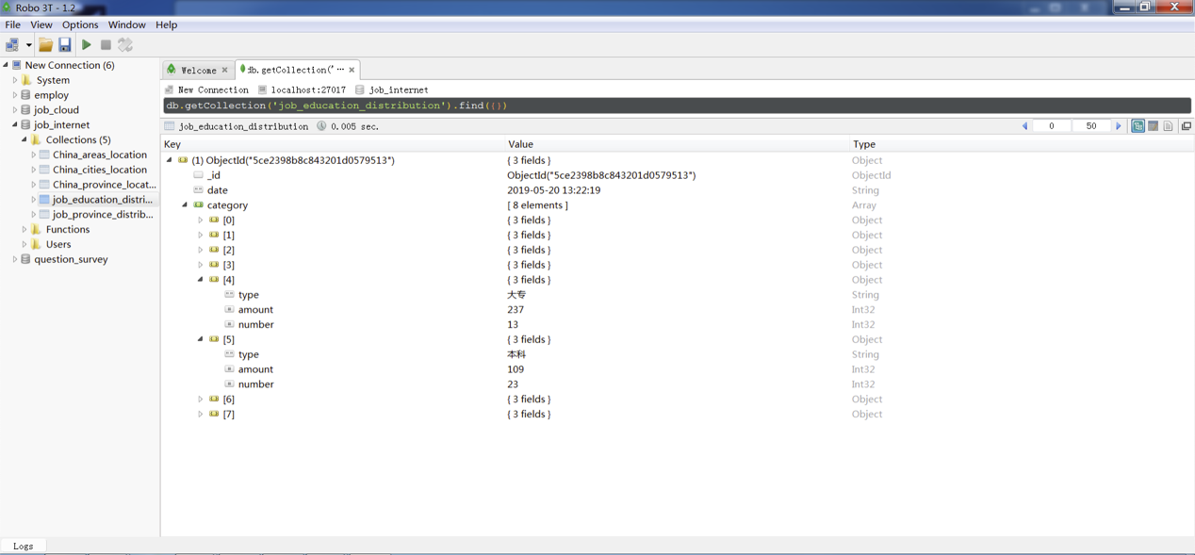

打开xueqing-client项目,修改com.xiandian.cloud.web.LearningController.java的getgwEchartsData函数，注释掉不需要的代码

/**

*

* **@author** xuanhuidong **@Description**: 岗位分析->数据统计 获取echarts数据 **@return** MessageBean

* 返回类型 **@throws**

*/

@RequestMapping("/gwechart")

@ResponseBody

**public** MessageBean getgwEchartsData(String id) {

Map<String, Object> map = **new** HashMap<>();

// 地区分布

Map<String, Object> echartsObjs1 = jobAnalysisReposity.getMap(mongoClient, id, ***province***);

map.put("province", echartsObjs1);

// 薪资

// Map<String, Object> map1 = jobAnalysisReposity.getSalary(mongoClient, id, salary);

// map.put("salary", map1);

// 学历

List<EchartsObj> echartsObjs2 = jobAnalysisReposity.getEducation(mongoClient, id, ***education***);

map.put("education", echartsObjs2);

// 经验

// List<EchartsObj> echartsObjs3 = jobAnalysisReposity.getExperience(mongoClient, id, experience);

// map.put("experience", echartsObjs3);

// 性质

// Map<String, Object> map2 = jobAnalysisReposity.getNature(mongoClient, id, nature);

// map.put("nature", map2);

// 规模

// Map<String, Object> map3 = jobAnalysisReposity.getScale(mongoClient, id, scale);

// map.put("scale", map3);

**return** **new** MessageBean(**true**, "", map);

}

运行xueqing-client项目，查看echarts图表

其他图表未实现

## 6.岗位聚类

根据给定的岗位数据源，使用指定的聚类或分类算法，进行 IT 行业的云计 算、大数据、移动互联、人工智能或物联网等行业进行岗位聚类分析，将数据保 存至 MongoDB 之中，实现 Web 前端代码并通过指定 EChart 的图表可视化展示。

修改com.xiandian.douxue.insight.server.service.job.cluster.JobCluster.java代码

修改cluster函数

/**

* 岗位循环聚类

*

* **@param** industry

* 岗位行业

* **@param** category

* 岗位行业类别

* **@param** dictionary

* 岗位技能点词典

* **@param** clusterN

* 聚类数量

* **@param** mongoClient

*/

**public** **void** cluster(String industry, String category, List<String> dictionary, **int** clusterN,

MongoClient mongoClient) {

List<String> id = **new** ArrayList<>();

List<String> jobname = **new** ArrayList<>();

**try** {

// id = jobDataReposity.queryDataByColumn("job_" + industry, industry, "ID");

// jobname = jobDataReposity.queryDataByColumn("job_" + industry, industry,

// "JOB_NAME");

id = *jobDataReposity*.queryDataByColumn("job_internet", "TAG_DATA", "ID");

jobname = *jobDataReposity*.queryDataByColumn("job_internet", "TAG_DATA", "JOB_NAME");

} **catch** (Exception e) {

// **TODO** Auto-generated catch block

e.printStackTrace();

}

Map<String, Map<String, String>> allJob = allJobClassification(id, jobname, industry);// 将取出的岗位群分类

List<String> ids = **new** ArrayList<>();

**if** (allJob != **null**) {

Map<String, String> category1 = allJob.get(category);// 取小类

**for** (Map.Entry<String, String> m : category1.entrySet())

ids.add(m.getKey()); // 取出所有开发类对应的ID

**if** (ids.size() > 1) {

List<String> jdes = **new** ArrayList<>();

List<String> jname = **new** ArrayList<>();

**try** {

// jdes = jobDataReposity.queryTableByCondition(ids, "job_" + industry,

// industry,

// "ID", "DESCRIPTION");

jdes = *jobDataReposity*.queryTableByCondition(ids, "job_internet", "TAG_DATA", "ID", "DESCRIPTION");// 根据ID取出所有开发类的岗位描述

jname = *jobDataReposity*.queryTableByCondition(ids, "job_internet", "TAG_DATA", "ID", "JOB_NAME");

} **catch** (IOException e) {

// **TODO** Auto-generated catch block

e.printStackTrace();

}

tfKmeans(jdes, jname, dictionary, industry, category, clusterN, mongoClient);// 对开发类岗位描述进行聚类

} **else**

logger.info(industry + "-" + category + " not enough data.");

}

}.

添加代码到kmeans函数

/**

* kmeans聚类算法

*

* **@param** des1

* 输入向量

* **@param** cluster

* 聚类数量

* **@return**

*/

**public** List<Integer> kMeans(List<**double**[]> des1, **int** cluster) {

List<Integer> indexs = **new** ArrayList<>();

SparkConf conf = **new** SparkConf().setMaster("local[2]")

.setAppName("xueqing-server").set("spark.driver.allowMultipleContexts","true");

JavaSparkContext jsc = **new** JavaSparkContext(conf);

JavaRDD<**double**[]> data = jsc.parallelize(des1);

JavaRDD<Vector> parsedata = data.map(s -> {

Vector value = Vectors.*dense*(s);

**return** value;

});

parsedata.cache();

KMeansModel clusters = KMeans.*train*(parsedata.rdd(), cluster, 20, 10);

indexs = clusters.predict(parsedata).collect();

jsc.stop();

**return** indexs;

}

修改Word2TF.Java代码

修改clean函数

/**

* 清洗岗位描述中技能点小于5个的描述

*

* **@param** dou

* **@return**

*/

**public** **static** List<Integer> clean(List<**double**[]> dou) {

List<Integer> index = **new** ArrayList<>();

**for** (**int** i = 0; i < dou.size(); i++) {

//if (sum(dou.get(i)) > 5) {

**if** (*sum*(dou.get(i)) >= 0) {

index.add(i);

}

}

**return** index;

}

修改word2string函数

/**

* 将一个字符串根据技能词典转换为以/分开的技能点

*

* **@param** str

* **@param** dictionary

* **@return**

*/

**public** **static** String word2string(String str, List<String> dictionary) {

**if** (str.equals("")) {

**return** "";

} **else** {

String vec = "";

**for** (**int** i = 0; i < dictionary.size(); i++) {

**if** (str.toLowerCase().contains(dictionary.get(i)))

vec = vec + dictionary.get(i) + "/";

}

//return vec.substring(0, vec.length() - 1);

**return** vec;

}

}

在JobClusterService的process函数里添加代码

/**

* 具体的实现。

*/

**public** ServiceState process() {/////

JobCluster jobCluster = **new** JobCluster();

mongoClient = *mongodbstorage*.setUp();

String jobConfig = ReadFile.*ReadFile*(System.*getProperty*("user.dir") + "/configuration/job_classification.json");

JSONObject jsonObject = **new** JSONObject(jobConfig);

JSONArray totals = jsonObject.getJSONArray("total");

**for** (**int** i = 0; i < totals.length(); i++) {

JSONObject total = totals.getJSONObject(i);

String industry = total.getString("industry");

JSONArray classfications = total.getJSONArray("classification");

**for** (**int** ii = 0; ii < classfications.length(); ii++) {

JSONObject classfication = classfications.getJSONObject(ii);

String category = classfication.getString("category");

String[] keywords = classfication.getString("keywords").split(",");

List<String> dictionary = **new** ArrayList<String>();

**for** (String keyword : keywords) {

dictionary.add(keyword);

}

jobCluster.cluster(industry, category, dictionary, clusterCount[0], mongoClient);

}

}

**return** ServiceState.***STATE_RUNNING***;

}

在com.xiandian.douxue.insight.server.service.job.JobAnalysisService.java里启动聚类服务并运行com.xiandian.douxue.insight.server.EduInsightServer.java，查看mongodb数据库

打开xueqing-clent项目，修改com.xiandian.cloud.common.learning.JobAnalysisReposity.java的getSkill函数

**public** Map<String, Object> getSkills(MongoClient mongoClient, String allparam, String param) {

// database job_cloud

String[] jobs = { "develop", "framework", "manage", "operation", "other", "sales" };

Map<String, Object> map = **new** HashMap<>();

List<String> weight = **new** ArrayList<>();

List<RaderObj> list = **new** ArrayList<>();

**for** (String str : jobs) {

String namestr = allparam + "_" + str;

String ss = *getJson*(mongoClient, allparam, namestr);

**if** (ss != **null**) {

JSONObject jsonObject = JSONObject.*fromObject*(ss);

JSONArray jsonArray = jsonObject.getJSONArray("category");

**for** (**int** i = 0; i < jsonArray.size(); i++) {

JSONObject jsonObject_ = jsonArray.getJSONObject(i);

String name = jsonObject_.getString("job_name");

**if** (name.equals(param)) {

JSONArray jsonArraySkills = jsonObject_.getJSONArray("skills");

**for** (**int** j = 0; j < jsonArraySkills.size(); j++) {

JSONObject jsonArraySkill = jsonArraySkills.getJSONObject(j);

**if** (!jsonArraySkill.isNullObject()) {

String Skill_name = jsonArraySkill.getString("Skill_name");

String Skill_weight = jsonArraySkill.getString("Skill_weight");

weight.add(Skill_weight);

RaderObj raderObj = **new** RaderObj();

raderObj.setMax(1);

raderObj.setName(Skill_name);

list.add(raderObj);

}

}

}

}

}

}

map.put("datasskill", list);

map.put("values", weight);

map.put("jobname", param);

**return** map;

}

运行xueqing-client项目，查看echarts图表

7.聚类岗位的主要技能图谱  
完成 xueqing-server 之中的聚类结果，提取每一个聚类结果中的主要技能点，

将数据保存至 MongoDB 之中，通过 EChart 指定的图表展示岗位的技能图谱。

默认已实现，查看echarts图表 

## 8.推荐岗位

给定一个学生的技能数据，使用机器学习推荐算法，帮助该学生推荐三个最 佳的招聘岗位，并通过 EChart 指定的图表展示推荐岗位和学生技能对比。

默认已实现，查看echarts图表 